Practical 6 & 7 Virology

1.Provide a flow diagram for the method part A(indirect ELISA )
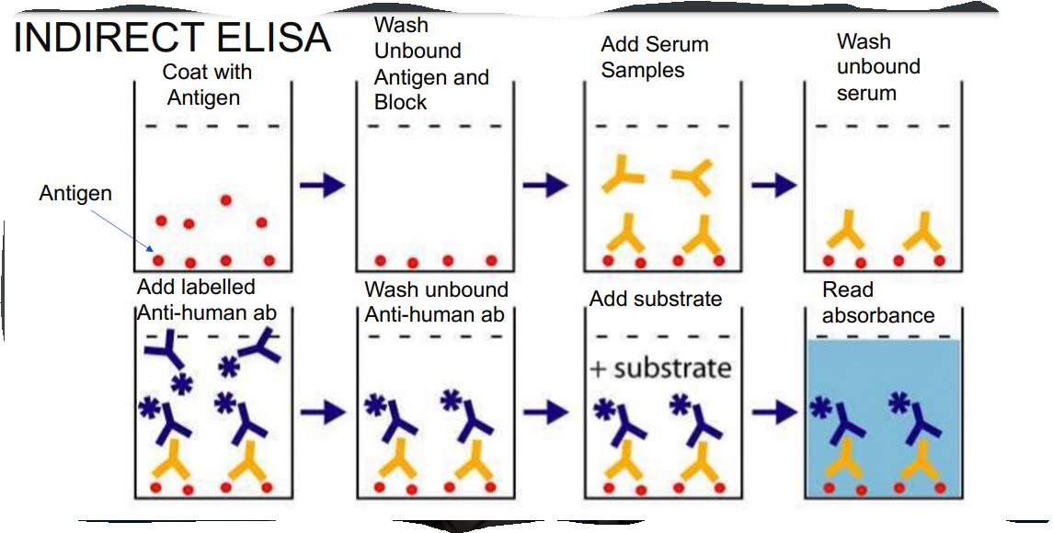

2. Document the mean absorbance for each sample and controls using data provided in Table 1
Dilution | Sample 1 | Sample 2 | Positive control | Negative control
A | 0.824 | 0.778 | 0.445 | 0.043
B | 0.601 | 0.492 | 0.262 | 0.057
C | 0.446 | 0.366 | 0.211 | 0.057
D | 0.308 | 0.288 | 0.172 | 0.052
E | 0.259 | 0.219 | 0.156 | 0.049
F | 0.226 | 0.172 | 0.127 | 0.049
G | 0.153 | 0.147 | 0.102 | 0.048
H | 0.118 | 0.122 | 0.090 | 0.050

3. Plot graphs of the mean of the duplicate absorbance vs log dilution for all samples using Table 1

4. Calculate the antibody titres by picking an absorbance reading in the linear part of the curve. The absorbance value you choose should be at least 0.1 units above the negative control serum absorbance at a dilution of 1/100. The antibody titre is the reciprocal of the dilution of antibody giving your chosen absorbance value. (In order to make a valid comparison, the same absorbance value must be used for all curves).
Absorbance value picked = 0.40
Antibody titre = reciprocal of the dilution of antibody
Dilution
= 1:100ul
= 46.25
$$∴ =0.4625$$
Reciprocal = $1÷0.4625 = 2.162$

5. What issues could arise if we were to use the N protein as antigen in our ELISA instead of S protein?
The N protein could give a false negative result. The S protein antigen test displays 98.4 % sensitivity and specificity above 90% already 10 days after symptoms onset allowing early detection of anti-S igG seroconversion while in N antigen it has higher sensitivity to samples collected 20 days after the onset of the symptom. considering that our samples were collected 7-10 days after the onset of the symptom the N protein could have a lower sensitivity leading to false positive results.
6. Provide a flow diagram for the method of Part B
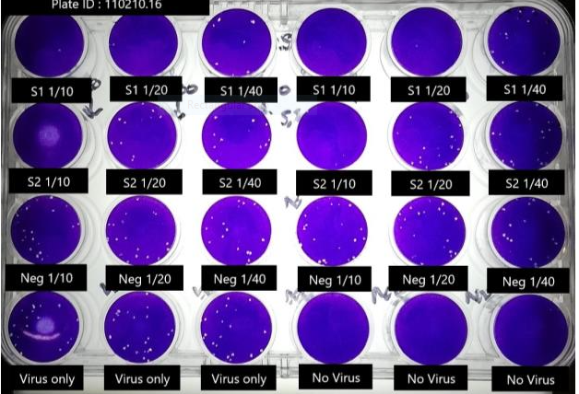
Row A: Duplicates of patient 1 serum dilutions.
Row B: Duplicates of patient 2 serum dilutions.
Row C: Duplicates of the negative control serum dilutions.
Row D: Three wells of the "virus only" control, three wells of the "no virus" control
7. Count plaques in all wells in Figure 1. Calculate the percentage plaque reduction at each serum dilution and estimate the titre. If there are virus specific neutralizing antibodies in the serum sample the number of plaques will be reduced compared to the same amount of virus incubated without serum. Antibody titre in this assay is normally reported as the reciprocal of the serum dilution giving a 50% reduction in plaque number. This may need to be calculated by interpolation. An alternative is to use the highest serum dilution giving a plaque reduction of 50% or greater
Plagues in sample 1
1/40 before incubation =15
After incubation =7
Percentage reduction =100% of plaques =15
8 cells
$∴ =$53.3%
Plaque in sample 2
1/40 before incubation =10
After incubation = 5
100%=10
5
$∴=$50%
8. Provide a flow diagram for the method of Part C.
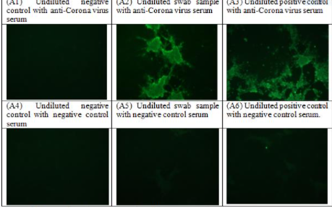

9.Briefly explain the outcome for each image (1 –2 sentences each)
A1- nothing is visible through the microscope. The sample is negative thus the anti –serum has nothing to feed on.
A2- spherical substance with spikes observed. This shows that the sample is positive and thus the anti-corona virus fed on the virus leaving the patches
A3-many spherical with spike patches. This gives evidence of a positive result as also shows that the anti-covid serum fed on the virus
A4 –nothing as seen through the microscope. There is no evidence of any virus
A5-less visible spikes – this evidence presence of the virus as there is a negative control serum
A6-spikes visible. Evidence presence of the virus as there was use of a negative control sample.
10. Briefly describe what information is gained through the techniques of part A, B and C. How is this different to the knowledge gained from PCR?
It is possible to utilize several antigen-antibody combinations in an ELISA test, as long as they contain an enzyme-labeled antigen or antibody. The enzyme activity is determined using a calorimetric method. Enzyme activity is assessed by measuring the color of a substrate that changes when it has been changed by the enzyme. The plaque assay (Figure 2) is based on the integration of host cells into the media, with log-phase growth being the preferred growth phase. This results in the formation of a dense, turbid layer of bacteria that is capable of supporting viral development. An isolated phage can infect, reproduce within, and lyse a single cell after being isolated. Because they use a polymerase chain reaction (PCR) to identify the viral genetic material of COVID-19, these tests are more reliable than fast testing in the case of a PCR infection. During a person's active disease, as well as after the acute illness, it is possible to find their genetic material.
11.which method, if any gives the truest measurement of anti-coronavirus antibodies? explain
Immunofluorescence assay – in immunofluorescence assay, Immunoglobulins that are specific for a protein of interest bind to that protein. Microscopy is used to visualize the protein of interest after it has been conjugated with fluorescent dyes in the immune complexes. It is more sensitive compared to other serological assays which can detect other viruses
12.how might we determine if one of the patients is infected but not yet showing symptoms, or if they have been previously exposed to Sars –cov2 virus
Performing a PCR test – the PCR test detect genetic material from the virus and produces its sequence. The test detects the presence of a virus if you have the virus at the time of the test. The test could also detect fragments of the virus even after you are no longer infected

13.you are preparing to present this work as a paper. Write an abstract complete with tittle for your paper based on this data.
EVALUATION OF ELISA TEST, PLAQUE REDUCTION ASSAYS AND IMMUNOFLUOROSCENT ASSAY
Background
It was around the end of 2019 that the Severe acute respiratory syndrome Corona Virus 2 ( SARS-CoV-2) outbreak, who's most common symptoms include; Fever, Fatigue, Cough and loss of taste, began and is currently ongoing. Averagely, it takes 5–6 days upon infection with the virus for symptoms to show. It can, however, take up to 14 days. There therefore, is a growing demand for reliable evaluation of a patient's serological status, as well as the detection of viral genome loads utilizing specific RT-PCR technologies.
Objective
Several different methods are currently in use in detecting antibodies to SARS-COV-2. We aimed at evaluating three serological based assays for performance in terms of Sensitivity in viral detection. These include immunofluorescence assay, Elisa test and plaque reduction assay.

Methods
Both an in-house immunofluorescence test, Elisa kits, and a plaque reduction assay were used to compare the results of two serum samples acquired from a group of high school kids who had begun to display symptoms of covid-19 and had been hospitalized. Blood samples and Nasopharyngeal swabs were taken and placed in virus carrying medium by the nurses at the covid -19 clinic.
ELISA Test
Antigen was bound to a solid surface (50ul of a mix containing 5ug of the coronavirus S protein in 5ml of carbonate buffer added to each well of the ELISA plate and incubated at 4ºC) .Dilutions of test serum were then added to the wells of the plate, allowing any antibodies specific for the coronavirus S protein to bind. Bound antibody was detected by addition of a polyclonal antiserum raised against human immunoglobulin and detection was via addition of a substrate plus a chromogen to produce a coloured reaction.
Plaque Reduction Assay
160μl of 1/10, 1/20 and 1/40 serum dilutions for each of the three serum samples was prepared.
160μl of each serum dilution was then mixed with 160μl of the diluted virus preparation and for controls, 250μl of the virus was mixed with 250μl of medium. One tube with 500μl of medium for the "no virus control" was therefore prepared. The tubes were incubated at 37ºC for 60 minutes. The virus-serum mixture was then aspirated and after this 1ml of cell culture medium was added to each well. The plates were then incubated for 3-4 days. Plaques were visible as holes in the cell monolayer where virus replication killed the cells.
Immunofluorescence assay
The medium was aspirated from the monolayers and to it, added 150μl of samples with negative and positive controls, swab sample and Duplicate. The inoculum was aspirated and replaced with 1ml of MEM. It was then Incubated for 3-4 days for the cytopathic effect. Addition of methanol to each monolayer of the cells for fixation then occur. After washing l, 50μl of anti-corona virus serum was added to each well in column 1,2,3 and normal human serum to columns 4, 5 and 6. Incubation for 30 minutes then occured before the addition of 50μl of goat-anti-human-IgG-FITC to each well. After incubation in the dark, plates were viewed using a fluorescent microscopy.
Results
SARS-COV-2 antibodies were not detected in any of the control subjects using any of the testing techniques. Estimated sensitivities for IgG detection ranged from 34.5 percent to 70 percent, while sensitivities for IgM detection ranged from 18 to 65 percent. In the case of IgG, the in-house IFA and ELISA showed 50-70 percent agreement with the other techniques. The intermethod agreement for IgM determination ranged from 25 to 75 percent, depending on the method.
Conclusion
In the aggregate, it was discovered that there was moderate agreement among the approaches. Because of the broad variety of testing methodologies, antigens used, and immunoglobulin isotypes analyzed, this discrepancy may be explained. Because the sensitivity of antibody detection in CoVID-19 was shown to be low, it is unlikely to be of much use. The evaluation of these procedures for SARS-CoV-2 IgG and IgM antibodies demonstrated that they had limited sensitivity and overall concordance, respectively, when compared to the other approaches. During the CoVID-19 pandemic, it is required to do additional study on the location and indications for serological status testing utilizing currently accessible technologies.

